**Project Coversheet**

|  |  |
| --- | --- |
| Full Name | Abdul Hannan |
| Email | abdulhannan00@myyahoo.com |
| Contact Number | 07352327791 |
| Project Title (Example – Week1, Week2, Week3) | Week1 |

**Project Guidelines and Rules**

**1. Formatting and Submission**

* Format: Use a readable font (e.g., Arial/Times New Roman), size 12, 1.5 line spacing.
* Title: Include Week and Title (Example - Week 1: Travel Ease Case Study.)
* File Format: Submit as PDF or Word file
* Page Limit: 4–5 pages, including the title and references.

**2. Answer Requirements**

* Word Count: Each answer should be within 100–150 words; Maximum 800–1,200 words.
* Clarity: Write concise, structured answers with key points.
* Tone: Use formal, professional language.

**3. Content Rules**

* Answer all questions thoroughly, referencing case study concepts.
* Use examples where possible (e.g., risk assessment techniques).
* Break complex answers into bullet points or lists.

**4. Plagiarism Policy**

* Submit original work; no copy-pasting.
* Cite external material in a consistent format (e.g., APA, MLA).

**5. Evaluation Criteria**

* Understanding: Clear grasp of business analysis principles.
* Application: Effective use of concepts like cost-benefit analysis and Agile/Waterfall.
* Clarity: Logical, well-structured responses.
* Creativity: Innovative problem-solving and examples.
* Completeness: Answer all questions within the word limit.

**6. Deadlines and Late Submissions**

* Deadline: Submit on time; trainees who fail to submit the project will miss the “Certificate of Excellence”

**7. Additional Resources**

* Refer to lecture notes and recommended readings.
* Contact the instructor or peers for clarifications before the deadline.

|  |
| --- |
| **YOU CAN START YOUR PROJECT FROM HERE** |

Title: Data Analysis for Business Insights

**Scenario:**

You are a Data Analyst working for ShopEase, an online retail company. The company wants to improve sales performance and customer satisfaction by analysing its sales data. Your task is to:

Steps of the project

Step 1 (Data collecting and data cleaning) 3

Step 2 (Data visualization) 4

Step 3 (final insights report) 7

# Step 1 (Data collecting and data cleaning)

This is the Dataset for ShopEase, an online retail company, Data contains columns transaction_ID ,Data, Customer_ID, product ,Category, Quantity ,Price, Total_Amount, payment _methods, region. This dataset has columns and 21 rows.

* **Missing values**: Dataset contains only one missing values , to calculate the value of total amount I have used basic multiplication method (price * quantity)

**Power query**

**=F2*G2**

* **Duplicate values:** to remove the duplicate values from the dataset , I have chosen Customer_ID column, which is unique and contains primary key, go to the **Formula** > **Remove duplicate values**

**Before removing duplicate value and missing values:**



* **Before removing duplicate value and missing values:**



# Step 2 (Data visualization)

I have used 3 different type of chart in excel to visualize the table

**Pivot table:**

|  |  |  |  |  |  |  |  |  |  |
| --- | --- | --- | --- | --- | --- | --- | --- | --- | --- |
| **sales in each month** | **Column Labels** |  |  |  |  |  |  |  |  |
| **Row Labels** | **Book** | **Headphones** | **Laptop** | **Shoes** | **Smartphone** | **Smartwatch** | **Tablet** | **T-Shirt** | **Grand Total** |
| Jan |  | 100 | 800 |  | 600 |  |  |  | 1500 |
| Jun | 20 |  |  |  | 600 | 200 | 500 |  | 1320 |
| May |  | 100 | 800 | 50 |  |  |  | 25 | 975 |
| Feb | 20 |  |  |  |  |  | 500 |  | 520 |
| Apr | 20 |  |  |  |  |  | 500 |  | 520 |
| Mar |  |  |  | 50 |  | 200 |  | 25 | 275 |
| **Grand Total** | **60** | **200** | **1600** | **100** | **1200** | **400** | **1500** | **50** | **5110** |

**Output**

**Insights:**

* **Best Month:** January (1,500 sales) – likely post-holiday or promotional boost.
* **Lowest Month:** March (275 sales).
* **Steady Sales:** April and February both at 520 sales.
* **Rising Trend:** May and June show recovery from earlier months.

**Pivot table:**



**output:**

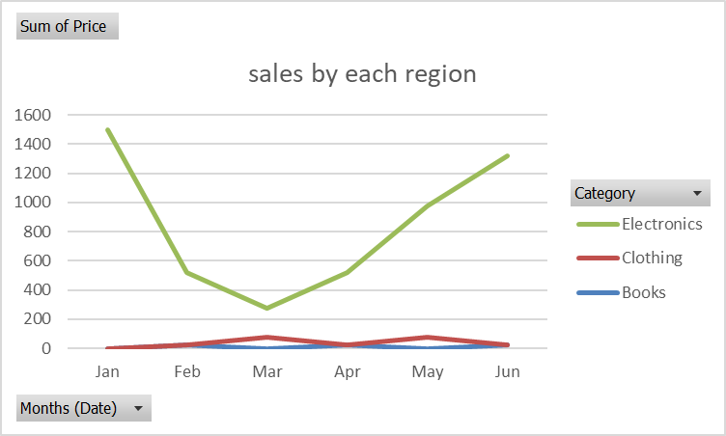

**Insights :**

* **Top Category:** Electronics dominate sales (95.9% of total).
* **Books & Clothing** contribute very little to total revenue.
* **Highest Sales Month:** January (entirely Electronics).
* **Lowest Sales Month:** March (lowest across all categories).
* Clothing sales are only present in March, May, and June.

**Pivot table:**



**Output:**

**Insights:**

* **Electronics lead in all regions**, but **East shows stronger Clothing interest**.
* **North region** performs best in Q1, especially January.
* **South region** peaks in June, suggesting summer campaigns are effective.
* **East and West** have moderate, consistent performance without big peaks.
* **Region-specific strategies** (like promoting Clothing in East) could improve overall revenue.

# Step 3 (final insights report)

**1(Queston and answer )**

* **What are the best-selling months or product categories?**  
  January stands out as the best-selling month, generating 1,500 sales, likely driven by post-holiday promotions and New Year campaigns. In contrast, March records the lowest sales at 275 units, signaling a significant seasonal dip. Moderate, steady sales were observed in February and April, while May and June show a positive upward trend, indicating recovery from the slower months. Regarding product categories, Electronics overwhelmingly dominate, accounting for 95.9% of total sales revenue. Books and Clothing contribute minimally, with Clothing sales appearing only sporadically in March, May, and June. These findings highlight Electronics as the core revenue driver and suggest seasonality significantly influences sales volumes.
* **Q: Are there any correlations between sales and factors like advertising spend?**  
  Sales trends strongly correlate with promotional activities and advertising efforts. January’s peak coincides with increased marketing spend associated with holiday aftermath campaigns, while June’s rising sales reflect successful summer promotional strategies, especially in the South region. Regional sales patterns further support this correlation: the North excels in Q1, particularly January, and the South peaks in June. Additionally, the East region’s distinct interest in Clothing suggests targeted marketing could further influence category-specific sales. Overall, strategic advertising timing appears critical in driving sales peaks, while months with lower promotional efforts, such as March, show decreased performance.
* **Q: What customer behaviours or purchasing trends were identified?**  
  Customer purchasing behaviour demonstrates a strong preference for Electronics year-round, with notable spikes during post-holiday and early summer periods. Clothing purchases are limited and seasonal, primarily concentrated in the East region during March, May, and June. The low sales in March indicate a potential off-peak period where customers are less engaged or where marketing activities are insufficient. Regional differences also reveal varied customer interests: the North region leads in early-year sales, while the South responds well to summer campaigns. These trends suggest that customers are responsive to targeted promotions, and purchasing is influenced by seasonality and regional preferences.
* **2) Provide Actionable Recommendations**
* **Q: How should the business focus marketing efforts based on peak sales periods?**  
  Marketing resources should be prioritized for January and June, aligning with observed peak sales periods. Concentrating advertising spend and promotional campaigns during these months will maximize impact and sales volume. Tailored regional campaigns, such as emphasizing summer promotions in the South and clothing-focused ads in the East, can further enhance performance. Additionally, leveraging data-driven insights to optimize timing and messaging will ensure campaigns resonate effectively with target audiences, increasing customer engagement and return on investment.
* **Q: What stock adjustments are recommended for best-selling products?**  
  Inventory management should reflect sales seasonality and category demand. Electronics stock levels must be increased ahead of peak months—especially January, May, and June—to prevent stockouts and meet customer demand efficiently. For Clothing, inventory should be adjusted to target the East region during months when sales occur (March, May, and June). This focused approach minimizes overstock risks while ensuring availability for key products in relevant regions. Regular stock reviews based on sales trends will support responsive supply chain management.
* **Q: What sales strategies should be adjusted for slow-performing months?**  
  For slow months like March, the business should implement targeted promotional campaigns to stimulate demand. Strategies might include limited-time discounts, flash sales, or bundling Electronics with slower-moving categories such as Books or Clothing to encourage cross-category purchases. Additionally, increasing advertising efforts during off-peak periods can raise customer awareness and engagement. Monitoring the effectiveness of these initiatives will allow timely adjustments and help sustain sales momentum throughout the year.

**3) Ethical Considerations**

* **Q: What ethical issues must the business consider regarding customer data?**  
  The business must prioritize data privacy by anonymizing customer information to prevent personal identification during analysis. Compliance with relevant regulations, such as the General Data Protection Regulation (GDPR), is essential, requiring informed consent for data collection and clear communication on data usage. Transparency and security measures should be maintained to protect customer trust. Ethical handling of data ensures compliance with legal standards while reinforcing the company’s reputation as a responsible steward of consumer information.
* **Bonus Challenge: Strategies to Boost Sales**
* **Q: Which months have the lowest sales and need attention?**  
  March is identified as the lowest-performing month, with only 275 sales, indicating a critical period for improvement. This off-peak month likely suffers from reduced customer engagement and insufficient marketing activity, necessitating focused intervention to boost sales and minimize revenue gaps.
* **Q: What two strategies could boost sales during low-performing months like March?**  
  To improve sales in March, the company should implement targeted promotions, such as flash sales or limited-time offers, to attract customer attention during this slow period. Secondly, offering discounts or bundle deals—especially combining popular Electronics with Books or Clothing—can incentivize larger purchases and increase overall sales volume. These strategies will help stimulate demand and counteract seasonal downturns.